UNIFINED MODELLING LANGUAGE

MỤC LỤC
1. KHÁI NIỆM CHÍNH TRONG NGÔN NGỮ UML 3
1.1 THINGS 3
1.1.1 Structural 4
1.1.1.1 Class 4
1.1.1.2 Interface 4
1.1.1.3 Collaboration 5
1.1.1.4 Usecase 5
1.1.1.5 Active Class 6
1.1.1.6 Component 6
1.1.1.7 Node 7
1.1.2 Behavioral 7
1.1.2.1 Interaction 7
1.1.2.2 State 7
1.1.3 Grouping 8
1.1.3.1 Package 8
1.1.4 Annotational 8
1.1.4.1 Note 8
1.2 Relationship 9
1.2.1 Dependency 9
1.2.2 Association 10
1.2.3 Generalization 13
1.2.4 Realization 14
1.3 Diagram 15
2. VIEW VÀ DIAGRAM 15
3. ARCHITECTURE 15
4. VÍ DỤ 15

KHÁI NIỆM CHÍNH TRONG NGÔN NGỮ UML

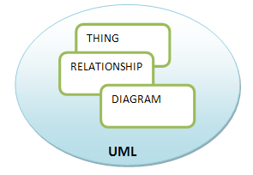
Ngôn ngữ mô hình UML cơ bản được gói gọn trong 3 block như trên. Với mỗi block chúng ta có thể có những khái niệm thể hiện những khía cạnh khác nhau.

THINGS
Là những khái niệm chính trong UML, nó gồm các phần tử thuộc các loại(khía cạnh):
Structural | Behavioral | Grouping | Annotational
Class | Interaction | Package | note
Interface | State
Collaboration
Use case
Active class
Component
Node

Structural
Structural things are the nouns of UML models. These are the mostly static parts of a model, representing elements that are either conceptual or physical.

Class
First, a class is a description of a set of objects that share the same attributes, operations, relationships, and semantics. A class implements one or more interfaces. Graphically, a class is rendered as a rectangle, usually including its name, attributes, and operations.
You use classes to capture the vocabulary of the system you are developing, These classes may include abstractions that are part of the problem domain, as well as classes that make up an implementation. You can use classes to represent software things, hardware things, and even things that are purely conceptual.
Symbol:
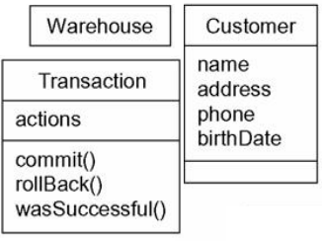

Interface
Second, an interface is a collection of operations that specify a service of a class or component. An interface therefore describes the externally visible behavior of that element. An interface might represent the complete behavior of a class or component or only a part of that behavior. An interface defines a set of operation specifications (that is, their signatures) but never a set of operation implementations.
it is typically attached to the class or component that realizes the interface.
Symbol:
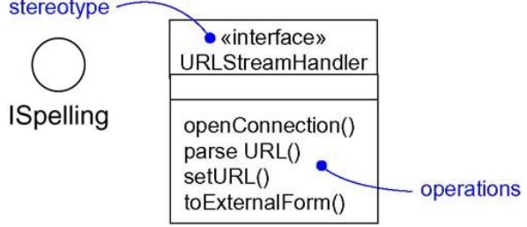

Collaboration
Collaboration defines an interaction and is a society of roles and other elements that work together to provide some cooperative behavior that's bigger than the sum of all the elements. Therefore, collaborations have structural, as well as behavioral, dimensions. A given class might participate in several collaborations. These collaborations therefore represent the implementation of patterns that make up a system.
The heart of a system's architecture is found in its collaborations, because the mechanisms that shape a system represent significant design decisions. All well-structured object-oriented systems are composed of a modestly sized and regular set of such collaborations, so it's important for you to organize your collaborations well.
Symbol:
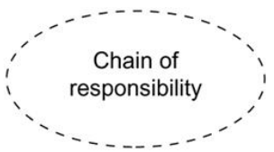

Usecase
use case is a description of set of sequence of actions that a system performs that yields an observable result of value to a particular actor. A use case is used to structure the behavioral things in a model. A use case is realized by a collaboration.
An actor represents a coherent set of roles that users of use cases play when interacting with these use cases. Typically, an actor represents a role that a human, a hardware device, or even another system plays with a system.
Symbol:
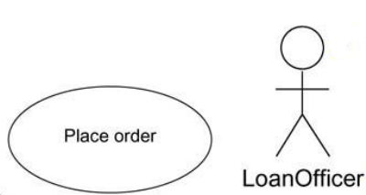

Active Class
an active class is a class whose objects own one or more processes or threads and therefore can initiate control activity. An active class is just like a class except that its objects represent elements whose behavior is concurrent with other elements
Symbol:
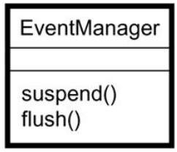

Component
A component is a physical and replaceable part of a system that conforms to and provides the realization of a set of interfaces. In a system, you'll encounter different kinds of deployment components, such as COM+ components or Java Beans, as well as components that are artifacts of the development process, such as source code files. A component typically represents the physical packaging of otherwise logical elements, such as classes, interfaces, and collaborations.
Symbol:
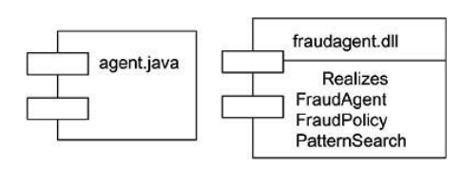

Node
a node is a physical element that exists at run time and represents a computational resource, generally having at least some memory and, often, processing capability. A set of components may reside on a node and may also migrate from node to node
Symbol:
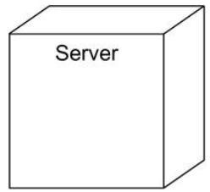

Behavioral
Là thành phần động của UML, thể hiện những ứng xử theo thời gian và không gian.

Interaction
an interaction is a behavior that comprises a set of messages exchanged among a set of objects within a particular context to accomplish a specific purpose. The behavior of a society of objects or of an individual operation may be specified with an interaction. An interaction involves a number of other elements, including messages, action sequences (the behavior invoked by a message), and links (the connection between objects).
Symbol:
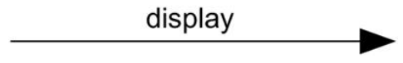

State
a state machine is a behavior that specifies the sequences of states an object or an interaction goes through during its lifetime in response to events, together with its responses to those events. The behavior of an individual class or a collaboration of classes may be specified with a state machine. A state machine involves a number of other elements, including states, transitions (the flow from state to state), events (things that trigger a transition), and activities (the response to a transition).
Symbol:
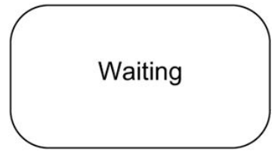

Grouping
Là thành phần thuộc về tổ chức của UML

Package
A package is a general-purpose mechanism for organizing elements into groups. Structural things, behavioral things, and even other grouping things may be placed in a package. Unlike components (which exist at run time), a package is purely conceptual (meaning that it exists only at development time).
Symbol:
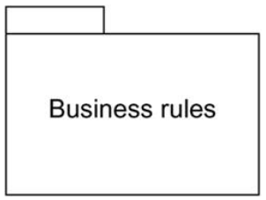

Annotational
Là những thành phần dùng để giải thích của UML

Note
A note is simply a symbol for rendering constraints and comments attached to an element or a collection of elements.
Symbol:
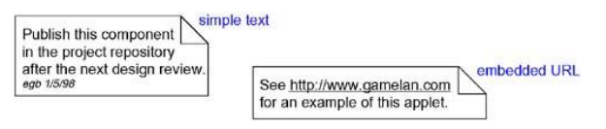

Relationship

Dependency
First, a dependency is a semantic relationship between two things in which a change to one thing (the independent thing) may affect the semantics of the other thing (the dependent thing). But not necessarily the reverse.
Most often, you will use dependencies in the context of classes to show that one class uses another class as an argument in the signature of an operation. if the used class changes, the operation of the other class may be affected, as well, because the used class may now present a different interface or behavior. In the UML you can also create dependencies among many other things, especially notes and packages.
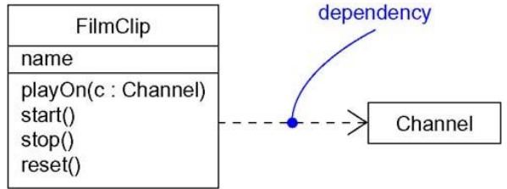

Advance Dependency
NAME | MEANNING
dependency relationships among classes and objects in class diagrams.
bind | Specifies that the source instantiates the target template using the given actual parameters.
derive | Specifies that the source may be computed from the target
friend | Specifies that the source is given special visibility into the target
instanceOf | Specifies that the source object is an instance of the target classifier
instantiate | Specifies that the source creates instances of the target
powertype | Specifies that the target is a powertype of the source; a powertype is a classifier whose objects are all the children of a given parent
refine | Specifies that the source is at a finer degree of abstraction than the target
use | Specifies that the semantics of the source element depends on the semantics of the public part of the target
dependency relationships among packages.
access | Specifies that the source package is granted the right to reference the elements of the target package
import | A kind of access that specifies that the public contents of the target package enter the flat namespace of the source, as if they had been declared in the source
dependency relationships among use cases
extend | Specifies that the target use case extends the behavior of the source
include | Specifies that the source use case explicitly incorporates the behavior of another use case at a location specified by the source
modeling interactions among objects
become | Specifies that the target is the same object as the source but at a later point in time and with possibly different values, state, or roles
call | Specifies that the source operation invokes the target operation
copy | Specifies that the target object is an exact, but independent, copy of the source
send | Specifies that the source operation sends the target event
trace | Specifies that the target is an historical ancestor of the source

Association
An association is a structural relationship that describes a set of links, a link being a connection among objects. Aggregation is a special kind of association, representing a structural relationship between a whole and its parts
An association is a structural relationship that specifies that objects of one thing are connected to objects of another, Use associations when you want to show structural relationships.
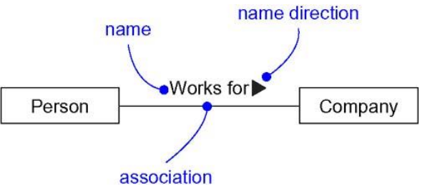

Role - When a class participates in an association, it has a specific role that it plays in that relationship; a role is just the face the class at the near end of the association presents to the class at the other end of the association. You can explicitly name the role a class plays in an association
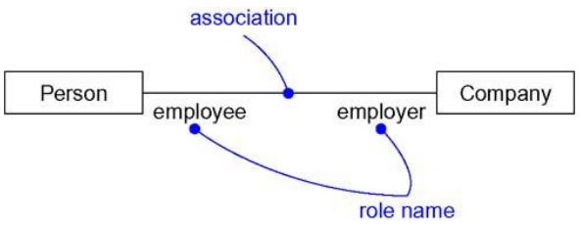
Multiplicity - An association represents a structural relationship among objects. In many modeling situations, it's important for you to state how many objects may be connected across an instance of an association. This "how many" is called the multiplicity of an association's role
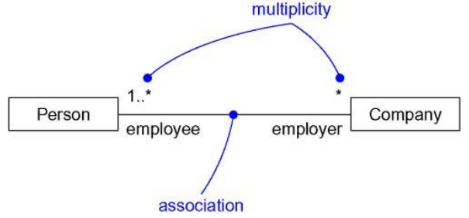
Aggregation - A plain association between two classes represents a structural relationship between peers, meaning that both classes are conceptually at the same level, no one more important than the other. Sometimes, you will want to model a "whole/part" relationship, in which one class represents a larger thing (the "whole"), which consists of smaller things (the "parts"). This kind of relationship is called aggregation, which represents a "has-a" relationship, meaning that an object of the whole has objects of the part. Aggregation is really just a special kind of association and is specified by adorning a plain association with an open diamond at the whole end.

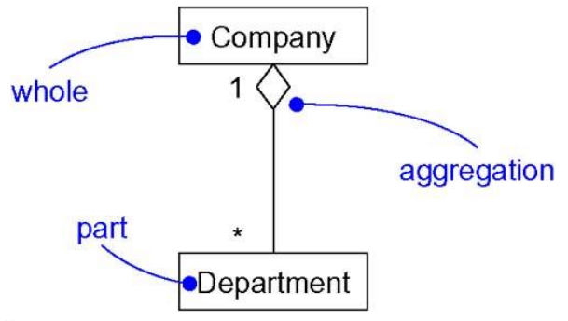

There are four basic adornments that apply to an association: a name, the role at each end of the association, the multiplicity at each end of the association, and aggregation. For advanced uses, there are a number of other properties you can use to model subtle details, such as navigation, qualification, and various flavors of aggregation.
Navigation - Given a plain, unadorned association between two classes, such as Book and Library, it's possible to navigate from objects of one kind to objects of the other kind. Unless otherwise specified, navigation across an association is bidirectional. However, there are some circumstances in which you'll want to limit navigation to just one direction.
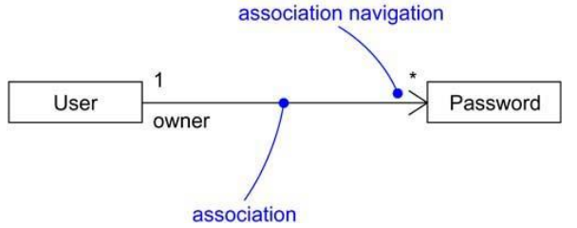
Note – ít dùng
Visibility – ít dùng
Qualification – ít dùng
Interface Specifier-ít dùng
Composition - Composition is a form of aggregation, with strong ownership and coincident lifetime as part of the whole. Parts with non-fixed multiplicity may be created after the composite itself, but once created they live and die with it. Such parts can also be explicitly removed before the death of the composite.
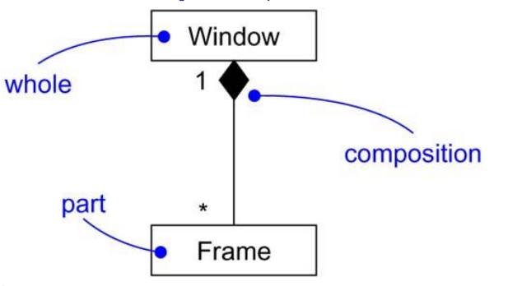
Association Classes - In an association between two classes, the association itself might have properties. For example, in an employer/employee relationship between a Company and a Person, there is a Job that represents the properties of that relationship that apply to exactly one pairing of the Person and Company. It wouldn't be appropriate to model this situation with a Company to Job association together with a Job to Person association. That wouldn't tie a specific instance of the Job to the specific pairing of Company and Person.
In the UML, you'd model this as an association class, which is a modeling element that has both association and class properties. An association class can be seen as an association that also has class properties, or as a class that also has association properties
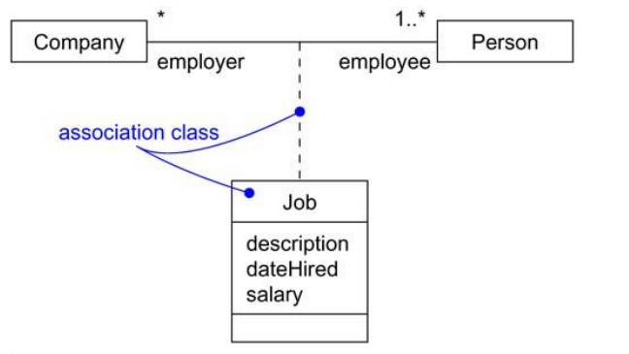

Generalization
A generalization is a specialization/generalization relationship in which objects of the specialized element (the child) are substitutable for objects of the generalized element (the parent). In this way, the child shares the structure and the behavior of the parent.
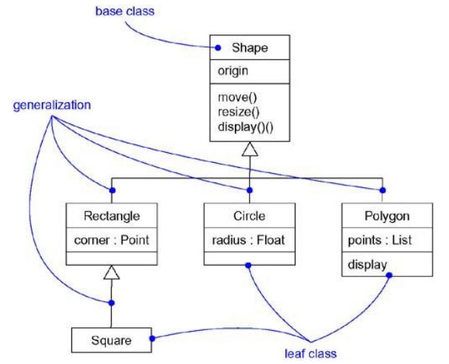
A plain, unadorned generalization relationship is sufficient for most of the inheritance relationships you'll encounter. However, if you want to specify a shade of meaning, the UML defines one stereotype and four constraints that may be applied to generalization relationships.
NAME | MEANNING
implementation | Specifies that the child inherits the implementation of the parent but does not make public nor support its interfaces, thereby violating substitutability
complete | Specifies that all children in the generalization have been specified in the model (although some may be elided in the diagram) and that no additional children are permitted
disjoint | Specifies that objects of the parent may have no more than one of the children as a type
overlapping | Specifies that objects of the parent may have more than one of the children as a type

Realization
a realization is a semantic relationship between classifiers, wherein one classifier specifies a contract that another classifier guarantees to carry out. You'll encounter realization relationships in two places: between interfaces and the classes or components that realize them, and between use cases and the collaborations that realize them.
You'll use realization in two circumstances: in the context of interfaces and in the context of collaborations.
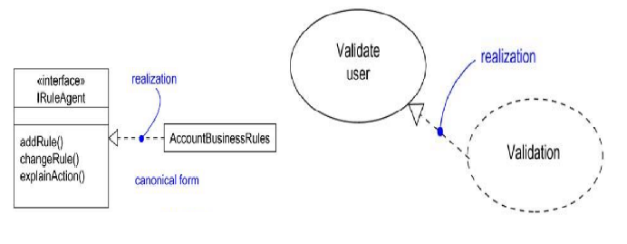

Diagram

VIEW VÀ DIAGRAM

ARCHITECTURE

VÍ DỤ
